Karli Mann & Myranda Robinson
Dr. Werner
Curriculum, Instruction, and Assessment
1 May 2015

Capstone Final Project: Artifact #10

SOLAR Lesson Plan

Grade Level: 3rd Grade
Subject Area: Mathematics (Introducing multiplying multiples of 2)
Materials Needed:
- White board, markers, magnets (At least 30), individual white boards, a cup of magnets for each student and markers for students.
- Worksheets (See attached) .
Standards: According to the NDDPI this lesson meets the standard of
- 3. oa.c.7 Fluently multiply and divide within 100, using strategies such as the relationship between multiplication and division.
Objectives:
- The students will be able to show the connection between addition and multiplication through visual aids and in class examples and practice.
- The students will be able to demonstrate understanding through the use of individual manipulatives.
Learning Activities:
0 min
- Start by introducing the lesson by referring to what the students already know: addition. Using a white board with magnets, place 8 magnets in a line, grouped in 4 groups, 2 in each group. Ask the students if they know how many are there. Ask for answers and how they found each answer. “You counted each one, right?” “You added them together.”
- Point out that the magnets are in groups. How many are in each group? Answer: 2 in each group. Under each group write 2 then add + signs between them to create a written equation. (2+2+2+2=___) Have the children solve this.
5 min
- Ask how many times 2 appears in the equation. Count aloud, pointing at each 2 in the equation and with your other hand use visual tallies until you count all the groups and reach 4. Ask how many TIMES did we say 2? So you’re telling me that you we said 2 (write 2) 4 (write 4) TIMES (write X) under the previous equation. You just did multiplication!
- Assure that every student understands how we reached the answer and how multiplication is just like addition. Repeat this process twice, using 2 different pre-selected examples.

- Add the multiples of 2 to the class chart
Ex:
 | 0 | 1 | 2 | 3 | 4 | 5 | 6 | 7 | 8
0 | 0 | 0 | 0 | 0 | 0 | 0 | 0 | 0 | 0
1 | 0 | 1 | 2 | 3 | 4 | 5 | 6 | 7 | 8
2 | 0 | 2 | 4 | 6 | 8 | 10 | 12 | 14 | 16
3
4
5
6
*Fill in multiples each day you go over them
15 min
- Have the children bring out their personal whiteboards and pass out a cup of magnets to each student. Reiterate that honesty is important, and that copying off your friends is not honest or beneficial and it is cheating. Rearrange the magnets into more examples on the board and have the students arrange their own at their desks and write the answer on their whiteboards and hold them up when they finish. Give each student think time, and allow them to work with partners grouped by proximity that is closest to them. Go over each answer, explaining how we got it. Use this time to check for understanding.
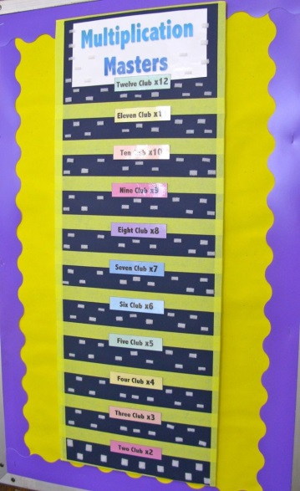
Pass out worksheets. (See attached) Have students work independently to complete.
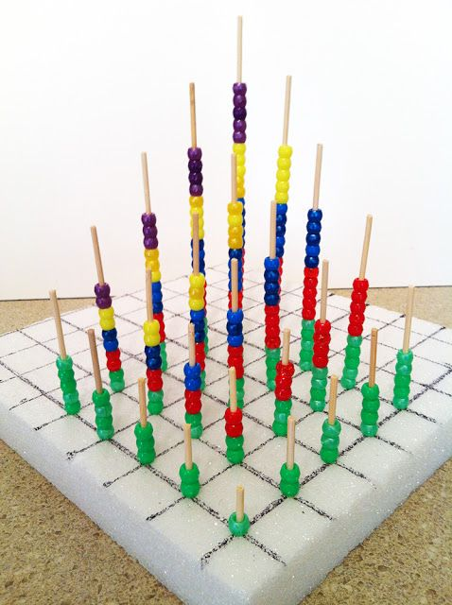
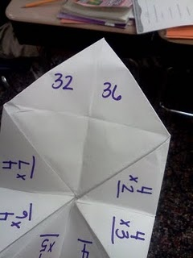
**In the weeks to come, students will be creating multiplication journals, as well as participating in math rotations to practice and memorize their multiplication tables with varying activities such as “soda pop top multiplication” and

Each day we will be doing a new set of multiplication tables (Ex. Day 1: multiples of 0 and 1 Day 2: multiples of 2...etc.)
Assessment:
- Assess understanding through the completion of the students’ worksheets in class.
- Assess understanding through observation during in-class examples verbally and on individual white boards with manipulatives.
Reflection
- To be completed after the lesson is taught.

Due: In class
Name___________________________________
Date________________________

Solve each equation first by adding and then by multiplying. MAKE SURE you pay attention to the signs in each equation (+ = Add and x = Multiply)

1.

_______ + _______ + _______ =

_______ x _______ =

2.

__________ + __________ =

__________ x __________ =

3.

_______+ _______+ _______+ _______+ _______ =

_______ x _______ =

4.
______+ ______+ ______+ ______+ ______ + _______=

_______ x _______ =

5.

________+ ________ =

________ x _______ =

Performance-Based Assessment
STANDARDS
- 3. oa.c.7 Fluently multiply and divide within 100, using strategies such as the relationship between multiplication and division.
OBJECTIVES
- The students will be able to show the connection between addition and multiplication through visual aids and in class examples and practice.
- The students will be able to demonstrate understanding through the use of individual manipulatives.
ACTIVITY
The students will be able to show the connection between addition and multiplication through visual aids and in class examples and practice using various manipulatives. Have the children bring out their personal whiteboards and pass out a cup of magnets to each student. Reiterate that honesty is important, and that copying off your friends is not honest or beneficial and it is cheating. Rearrange the magnets into more examples on the board and have the students arrange their own at their desks and write the answer on their whiteboards and hold them up when they finish. Give each student think time, and allow them to work with partners grouped by proximity that is closest to them. Go over each answer, explaining how we got it. Use this time to check for understanding.
**See Lesson plan for beginning multiplication

 | Exemplary | Proficient | Partially Proficient | Novice
Make sense of problems and persevere in solving them | Student stayed on-task, grasped the concept and solved the problems correctly with no difficulty | Student stayed on-task, grasped the concept and solved the problems correctly with minimal difficulty | Student stayed on-task with reminders, grasped the concept after teacher/peer prompting and solved problems with some difficulty | Student was off-task, did not understand material and did not solve the problems
Use of manipulatives individually/ in small groups | Student used manipulatives purposefully to find the correct answer and fully understood the abstract concept in a concrete way | Student used manipulatives appropriately and demonstrated the task as prescribed, producing the correct answer | Student used manipulatives appropriately, with some redirection needed from the teacher and required teacher or peer assistance | Student did not use manipulatives appropriately, and needed redirection often (needs re-teaching)
Participation in class (large group) | Student was eager to participate, answered questions, and followed along with the activity on his/her personal white board before the large group was ready to move on | Student participated in the activity on his/her white board, and followed along at the teacher’s pace without redirection needed | Student participated in the activity, required some assistance from teachers/peers and some redirection | Student did not participate in the activity, did not answer questions, and was distracted with personal white board
3rd Grade Multiplication Performance-Based Rubric
Name__________________________________
Date___________________

*adapted from
http://www.exemplars.com/resources/rubrics/assessment-rubricsn

Name_______________________________________
Date______________________
Multiplication and Division Unit Test

True/False: Write the letter T if the statement is true and the letter F if the statement is false.
1. _____ The answer in a multiplication problem is called the product.
2. _____ Becky has 21 flowers. She puts 7 flowers in a vase. Becky has 3 vases.
3. _____Billy has 56 baseball cards. He wants to divide them into 7 equal piles. He could solve this by subtracting 7 from 56 to find out how many baseball cards he will have in each pile.
4. _____ 7 x 5 is the same as 5 x 7
5. _____ 81 ÷ 9 is the same as 9 ÷ 81
6. ______ 9 x 9= 108
Explain why or why not?

7. ______Janet has 32 cupcakes. She wants to put 8 cupcakes on each plate. She would solve this by 32 + 8. If false, correct to make statement true.

Multiple Choice: Circle the correct answer(s) to each of the following questions.
8. What are TWO ways to show how to find the value of 10 x 4 ?
Select the TWO correct answers.
a. 4 groups of 10 ones
b. 10 groups of 4 tens
c. 4 x 10
d. 10 x 4 x 40
9. Robert solved the math problem shown.
8×7=
Which equation can Robert use to check his answer?
a. ?+7=8
b. 8+?=7
c. 7÷?=8
d. ?÷8=7
10. What is 6 multiplied by 5?
a. 30
b. 35
c. 15
d. 25
11. What is the quotient of 63 and 7?
a. 6
b. 9
c. 8
d. 7
12. What is the product of 4 and 3?
a. 8
b. 15
c. 12
d. 18

Use the following diagram to answer questions 13-14
13. These are Amy’s marbles. She wants to make bags with equal numbers in each bag. How many marbles would be in each bag if she had 4 bags?
a. 2
b. 3
c. 4
d. 5
14. How many combinations of marbles and bags are there if Amy wants to have equal numbers in each bag?
a. 12
b. 7.
c. Not possible
d. 4

Short Answer: Write 1-2 sentences answering each of the following questions.
15. Clifford is using a multiplication table to find the value of n that makes the equation 27÷7=n true. His answer is 3. Do you agree? Explain.

16. When you divide, do you put the smaller number in front of the smaller number such as 3 ÷12? Why or why not?

Essay: Write 3-5 sentences answering the following question.
17. Andrew has 11 Oreos. He wants to share them equally with his 2 brothers. Can he do this? Why or why not?

Matching: Write the correct letter on the line provided. Some answers may not be used.
_____ 2 x 8 x 2=
_____ The answer to a multiplication question
_____ One hundred and forty four divided by twelve equals
_____ The answer to a division question
_____ 56 divided by 7 equals
_____2+2+2+2 is the same as:
_____ A way to check your answer for 5x7
_____ 9x1x1=
_____6x3=
_____ 4x4=

A. Eleven
B. 18
C. Eight
D. Dividend
E. 35 ÷ 7
F. 2 multiplied by 4
G. 32
H. Quotient
I. 12
J. 9
K. 1
L. Multiplier
M. 16
N. Product

Name_____________________________________
Date___________________
Multiplication and Division Unit Test
KEY

True/False: Write the letter T if the statement is true and the letter F if the statement is false.
1. __T__ The answer in a multiplication problem is called the product.
2. __T__ Becky has 21 flowers. She puts 7 flowers in a vase. Becky has 3 vases.
3. _F___ Billy has 56 baseball cards. He wants to divide them into 7 equal piles. He could solve this by subtracting 7 from 56 to find out how many baseball cards he will have in each pile.
4. _T__ 7 x 5 is the same as 5 x 7
5. __F__ 81 ÷ 9 is the same as 9 ÷ 81
6. __F__ 9 x 9= 108
Explain why or why not?
9 x 9 = 81 because if you had 9 groups, and put 9 objects into each group, you would have 81 items
7. __F__ Janet has 32 cupcakes. She wants to put 8 cupcakes on each plate. She would solve this by 32 + 8. If false, correct to make statement true.
Janet would have to divide 32 and 8 so there would be equal cupcakes on each plate
Multiple Choice: Circle the correct answer(s) to each of the following questions.
8. What are TWO ways to show how to find the value of 10 x 4 ?
Select the TWO correct answers.
a. 4 groups of 10 ones
b. 10 groups of 4 tens
c. 4 x 10
d. 10 x 4 x 40
9. Robert solved the math problem shown.
8×7=
Which equation can Robert use to check his answer?
a. ?+7=8
b. 8+?=7
c. 7÷?=8
d. ?÷8=7
10. What is 6 multiplied by 5?
a. 30
b. 35
c. 15
d. 25
11. What is the quotient of 63 and 7?
a. 6
b. 9
c. 8
d. 7

12. What is the product of 4 and 3?
a. 8
b. 15
c. 12
d. 18

Use the following diagram to answer questions 13-14
13. These are Amy’s marbles. She wants to make bags with equal numbers in each bag. How many marbles would be in each bag if she had 4 bags?
a. 2
b. 3
c. 4
d. 5
14. How many combinations of marbles and bags are there if Amy wants to have equal numbers in each bag?
a. 12
b. 7.
c. Not possible
d. 4
Short Answer: Write 1-2 sentences answering each of the following questions.
15. Clifford is using a multiplication table to find the value of n that makes the equation 27÷7=n true. His answer is 3. Do you agree? Explain.
Yes. Because if you took 27 objects and put them into 7 piles, you would have 3 piles.
16. When you divide, do you put the smaller number in front of the smaller number such as 3 ÷12? Why or why not?
No. You put the larger number in front because if you put the smaller number in front you will get a fraction.
Essay: Write 3-5 sentences answering the following question.
17. Andrew has 11 Oreos. He wants to share them equally with his 2 brothers. Can he do this? Why or why not?
Eleven is a prime number. This means that it is not divisible by any other number than itself. It is unable to be divided evenly, meaning Andrew is not able to equally share his Oreos with his brothers.

Matching: Write the correct letter on the line provided. Some answers may not be used.
_G__ 2 x 8 x 2=
N__ The answer to a multiplication question
_I___ One hundred and forty four divided by twelve equals
_H___ The answer to a division question
C____ 56 divided by 7 equals
__F___ 2+2+2+2 is the same as:
__E__ A way to check your answer for 5x7
_J___ 9x1x1=
__B___ 6x3=
M___ 4x4=

A. Eleven
B. 18
C. Eight
D. Dividend
E. 35 ÷ 7
F. 2 multiplied by 4
G. 32
H. Quotient
I. 12
J. 9
K. 1
L. Multiplier
M. 16
N. Product

