I Want to Build a House: Classroom Management
Myranda Robinson
28 April 2015
University of Mary

I Want to Build a House: Classroom Management
I want to build a house. I want to build a fantastic house. I have everything I need too. I have a wonderful roof picked out, extremely durable against high winds, hail, sleet, and other extreme weather phenomena. I picked out brick walls that will add an artistic allurement of historical appeal and fantasy to the presentation of my house. And my door! You should see it, painted an excellent red. Cute, fun, and inviting to all who wish to enter to explore and learn. I pieced all the wonderful elements together and sure enough in a matter of hours my house came tumbling down. Why did it fall? Why did it fold and falter? My roof was sturdy, my walls were stable, and my door was welcoming and assessable. What was I missing?
My foundation. I was missing my foundation!
When I think of classroom management I think of it as the foundation of a house and every other element builds from this foundation to create an enchanting and lovely house (exceptional learning environment). It is the first thing you need to install before you decorate your curriculum with exciting learning activities and your creative, standard driven lessons. It is and should be the foundation to all elements of your school day. It is the stable piece that every portion of your day derives from. Classroom management is more than just seating charts or directions to hopefully navigate your classroom smoothly. It is an expectation that is placed on each and every one of your students from the moment they step in to your class, until the moment they leave (Marzano, 2003).
These expectations do not come all at once however. They come day by day as they begin to present themselves through the first couple days and weeks of school. I had the privilege to observe and practice classroom management in a third grade classroom this past semester through my block one practicum. If I were to use third grade as an example the first days of school would look remotely different than they would if I were in an early childhood or secondary classroom. For the first days in the third grade you would want to do “ice breakers” to get the students talking to one another and warming up to their new supporters and motivators (Their peers).
From here I would have them do an activity to which they would draw a picture and write below a description of a fun activity that took place that summer. Students then could come up in front of the class and share what made their summer so much fun. This breeds the allowance and understanding that each and every child has a voice and their voice has a time and a place when it should be heard. When it is not the student’s turn to present, they are to sit in silence and respectfully listen to their new classmates (Am I already sensing the subtle instilment of classroom management?) This also allows for you as a teacher to see personalities and learn what makes the student an individual, separating them from no longer being just a name on your roll call sheet.
The next day you could plan a mini scavenger hunt around the room so students become familiar with where the pencil sharpener, take home baskets, color pencils, smart board are, etc. Once every student has completed the scavenger hunt successfully you could collectively go through the list and address the functions, rules, and expectations of each item in the classroom (Ex. You are allowed to use the pencil sharpener, but not when the teacher is talking or other students are presenting, because it is disrespectful). Right there, in one simple, FUN activity you are instilling yet again another portion of your classroom management piece by explaining to them what you expect behavior should look like now as a third grader!
As the first days turn to weeks, and the weeks turn into months you will establish a connection with your students naturally. As humans we have the innate ability to connect by simply our presence alone. Actions and words touch and resonate without our even apparent knowledge. This is because we desire relationships. It is what fuels us, motivates us, and utility teaches us. So if we already have that predisposition to connect with our students, can you imagine what happens when we put in the effort to fully and completely connect with them and their families at more than a simplistic or superficial level?
Connection is driven by empathy. It is the ability to extract yourself from your present life and meet another at whatever place or level they currently exist at. This goes beyond knowing them as a student. This is knowing them as an individual third grader who loves the color pink and dislikes pickles, or whose parents are divorced and the weekend he stays with dad his homework is never signed. It is working with the parents and keeping them completely and entirely informed daily, weekly, or whatever is needed for the particular student to meet the expectations and make the deadlines for assignment, tests, and projects. It is being that open-minded, judgment free stranger that implements themselves purposefully in to these students’ lives to help mold, create, and inspire them to be the best that they can potentially be.
However, this is sometimes easier said than done. What if the family does not have a working phone line or email address? Or what if the student does not get the parents the paper notifications that you send home or the parents do not care to ask for them? What if the student does not have a safe home environment? What if they do not get enough sleep because they do not have a constant stable home to go home to each night? These “what if” situations are endless and can be much more devastating and heartbreaking. The answer of what to do is found within adaptation and flexibility. It is altering forms of communication, maybe you will have to make home visits or schedule times to have the parents meet with you weekly at the school or place of convenience. It could be finding time for the student to complete assignments within the school day, if they are unable to have internet access at home or there is a reoccurring theme of incompletion. Maybe it will result in working with the school counselor or social services. It is all dependent on the individual child and remembering that education is fair but not equal. Not all students get the same, they get what they need.
What is helpful when looking at how you will manage your classroom and how your students will develop as students throughout the year is not solely dependent on what you do alone as a teacher. Remember that you are a part of something bigger. You are a part of a school system that hopefully has the same ambitious attitude as you do about the importance of classroom management. What works best is finding a common understanding and definitive game plan in how punishment and discipline will take place within your school system. Jim Fay states in his book of Love and Logic that the worst mistake a school system can make is letting the students put a wedge between the administrator and teachers. They are to be on the same team working together cohesively to better the student, which also securers the importance and structure of classroom management you have already instilled (Fay, 2011).
Having classroom management is to help the frequent outbursts, tantrums, or inappropriate behavior, but that is not to say that they will not occur. There will still be instances where a trip to see the principal is the best way to deal with a particular situation or student. Fay explains though, it is all about how you go about sending them down to the office. If you abruptly send them away, they go down and talk to the principal and come back and the behavior is still the same, the teacher could become aggravated or distraught because nothing was “done” to fix or change the situation. What is placed here is the disconnect between teacher and principal, all they know is hear say from the mischievous student. Fay suggests that instead of sending the student down, the teacher make an appointment with the principal, the student, and him/herself to make sure all is correctly stated in context and expectations and disciplinary actions are the same across the board (Fay, 2011).
Overall, classroom management encompasses all a teacher does in the structuring of their classroom. The form of classroom management will dictate how students will behave and thrive in the alleged set foundation. I believe what is key about classroom management is to simply not forget about it. It is important. It is one of the most important elements you will instill as a teacher. So go! Go build that house, decorate with creative, fun, nurturing, standard filled lessons and connecting relationships, but remember to put in your foundation first!
Appendix:
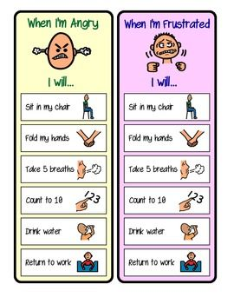
https://www.pinterest.com/pin/210191507585706777/
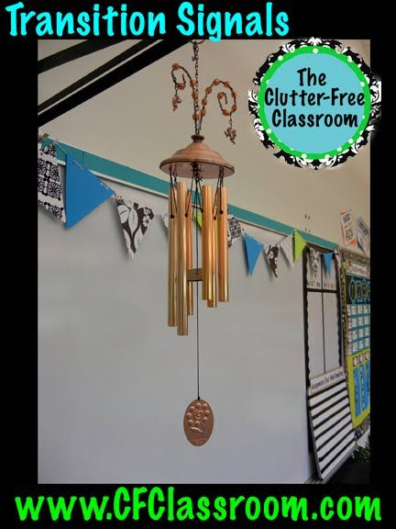
https://www.pinterest.com/pin/252975704045615169/
https://www.pinterest.com/pin/159455643026136301/
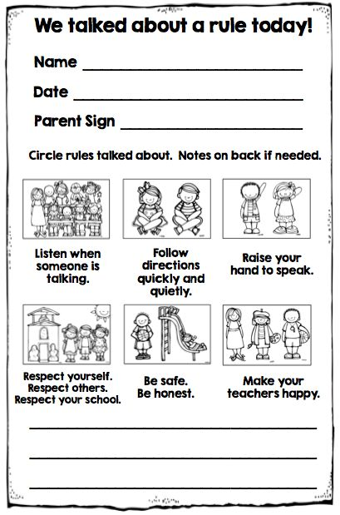
https://www.pinterest.com/pin/26880929002524576/
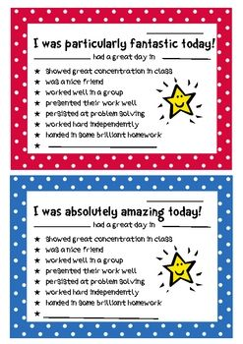
https://www.pinterest.com/pin/80713018291854436/

References
Fay, J. (2011). Creating a Love and Logic School Culture. Golden, CO: Love and Logic
Institute, Inc.
Marzano, R., Marzano, J. & Pickering, D., (2003). Classroom management that works:
Research-based strategies for every teacher. Alexandria, VA: ASCD.
Pinterest (Links placed under pictures in appendix).

